Week 14 - Tuesday Project 3 Planning

1. We met with our team. Our team’s name is Spring Spartans (Angular Agents). The team leader of the Spring Spartans is Sean O’ Dowd.

2. This is the ER Diagram for our database. The first rough draft was done using discord’s diagram feature, and the second was done using the app diagram website.

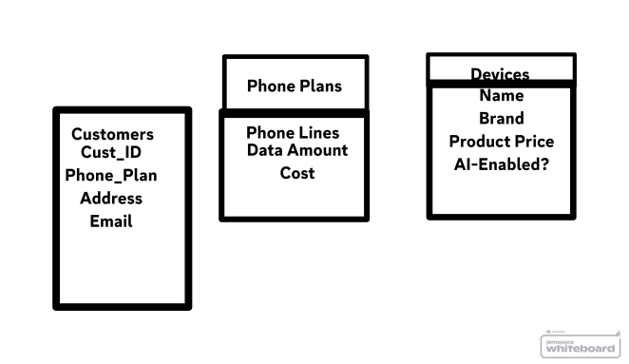

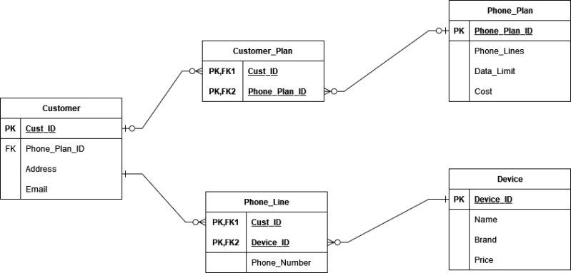

3. Mock-up of the frontend

4. Trello board (Ice Box, TODO, In Progress, Done)

